**DAILY ONLINE ACTIVITIES SUMMARY**

|  |  |  |  |  |  |  |  |  |
| --- | --- | --- | --- | --- | --- | --- | --- | --- |
| Date: | 27/06/2020 | | | | | Name: | Jyothi B R | |
| Sem & Sec | IV-A | | | | | USN: | 4AL18CS030 | |
| Online Test Summary | | | | | | | | |
| Subject | | Data Communication. | | | | | | |
| Max. Marks | | 28 | | Score | | | 30 | |
| Certification Course Summary | | | | | | | | |
| Course | Programming Essentials in Python | | | | | | | |
| Certificate Provider | | | Cisco Virtual Academy | | Duration | | | 3hrs |
| Coding Challenges | | | | | | | | |
| |  |  | | --- | --- | | Problem statement :  Given start and end of a range, write a Python program to print all negative numbers in given range. |  | | | | | | | | | |
| Status:Completed | | | | | | | | |
| Uploaded the report in Github | | | | | Yes | | | |
| If yes Repository name | | | | | https://github.com/alvas-education-foundation/jyothi_b_r | | | |
| Uploaded the report in slack | | | | | Yes | | | |

Online Test Details: (Attach the snapshot and briefly write the report for the same)

Certification Course Details: (Attach the snapshot and briefly write the report for the same)

Coding Challenges Details: (Attach the snapshot and briefly write the report for the same)

**ONLINE TEST DETAILS:** The online test was from modules 5, all the questions were objective type questions. All questions were optimal and were easy. The score that I got was 28/30.

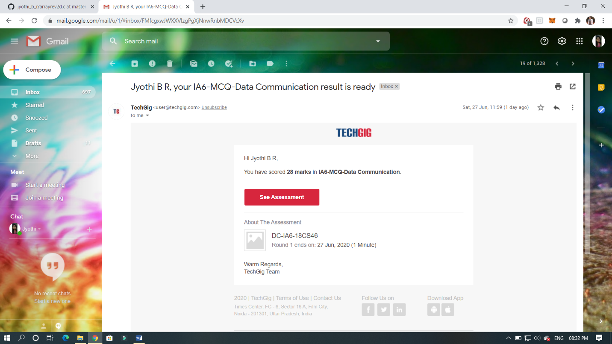

CERTIFICATION COURSE DETAILS:

Programming Essentials in Python :

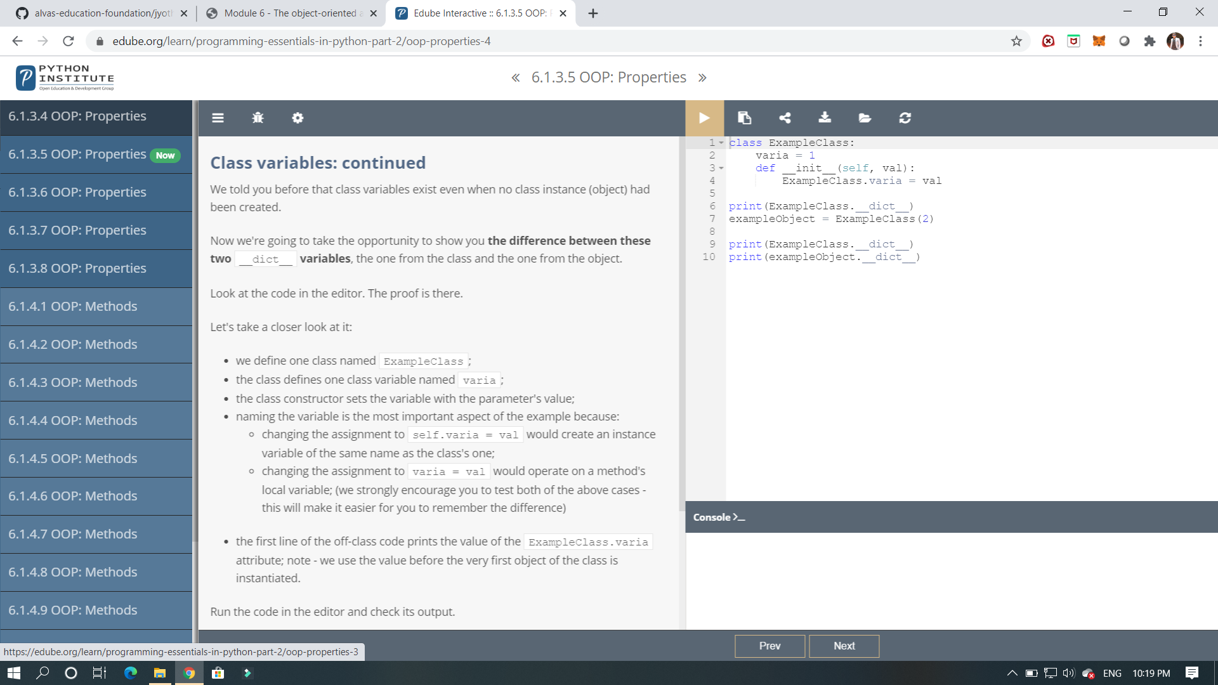

IT’S A NEXT MODULE ,IT SHOWS ABOUT THE OBJECT ORIENTED APPROCH AND FOUNDATIONS.

And it shows about the object approach and classes variables. and it shows the implementation for variables how it can be used.

ONLINE CODING :  write a Python program to print anagram of a string. 